Gym Management App

1. Project overview
Proposed product: Gym Management System with AI Fitness Assistance.
Objective: Build a full-stack web application that helps a gym manage members, trainers, membership subscriptions, payments, attendance, workout plans, and fitness recommendations through a single platform.
The system will have three authenticated roles:
- Member: manages their membership, bookings, fitness goals, and progress.
- Trainer: manages assigned members, workout plans, and training sessions.
- Admin: manages gym operations, staff, membership plans, payments, and reporting.
The public landing page will allow visitors to view plans, classes, and gym information before signing up.

Working assumption
This initial R&D assumes one physical gym with one Admin-controlled organization. We can adapt it to multiple gyms later if that is the actual business requirement.

2. Main application control flow
This is the high-level flow to use in your R&D document.
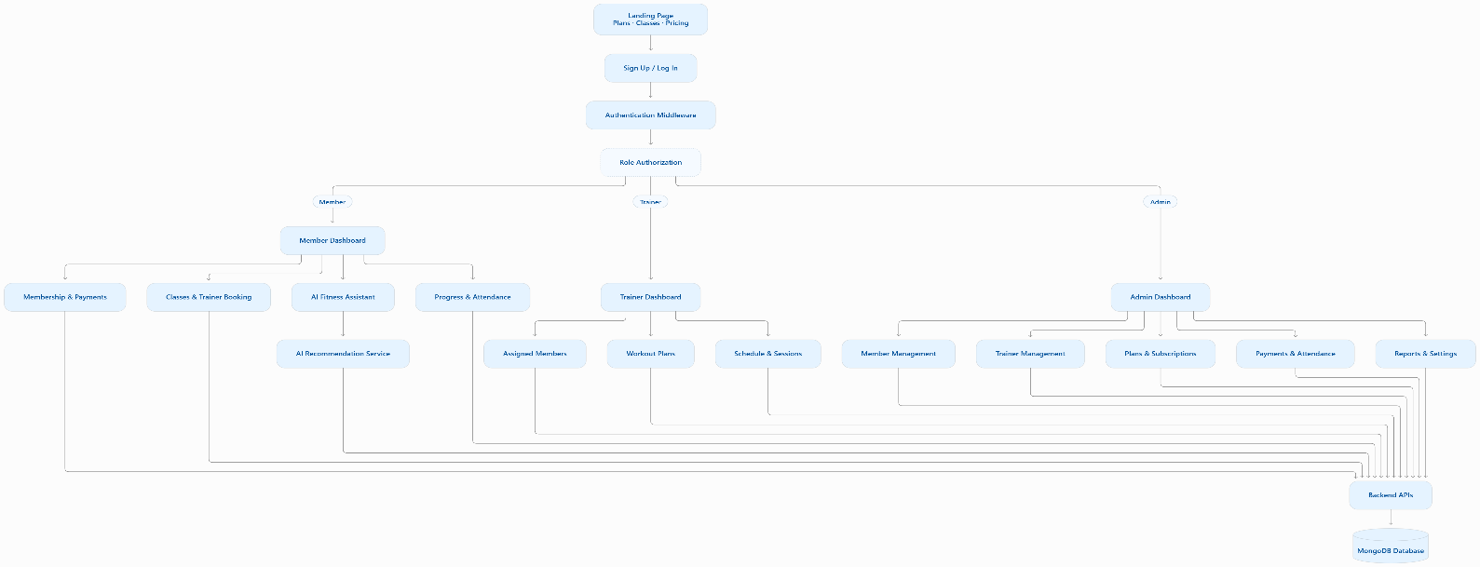
Architecture principle: all three areas use the same backend and database, with access controlled by the server. The AI recommendation service is an additional component that the backend calls when needed; it should not bypass authentication or database permissions.

3. Member-side workflow
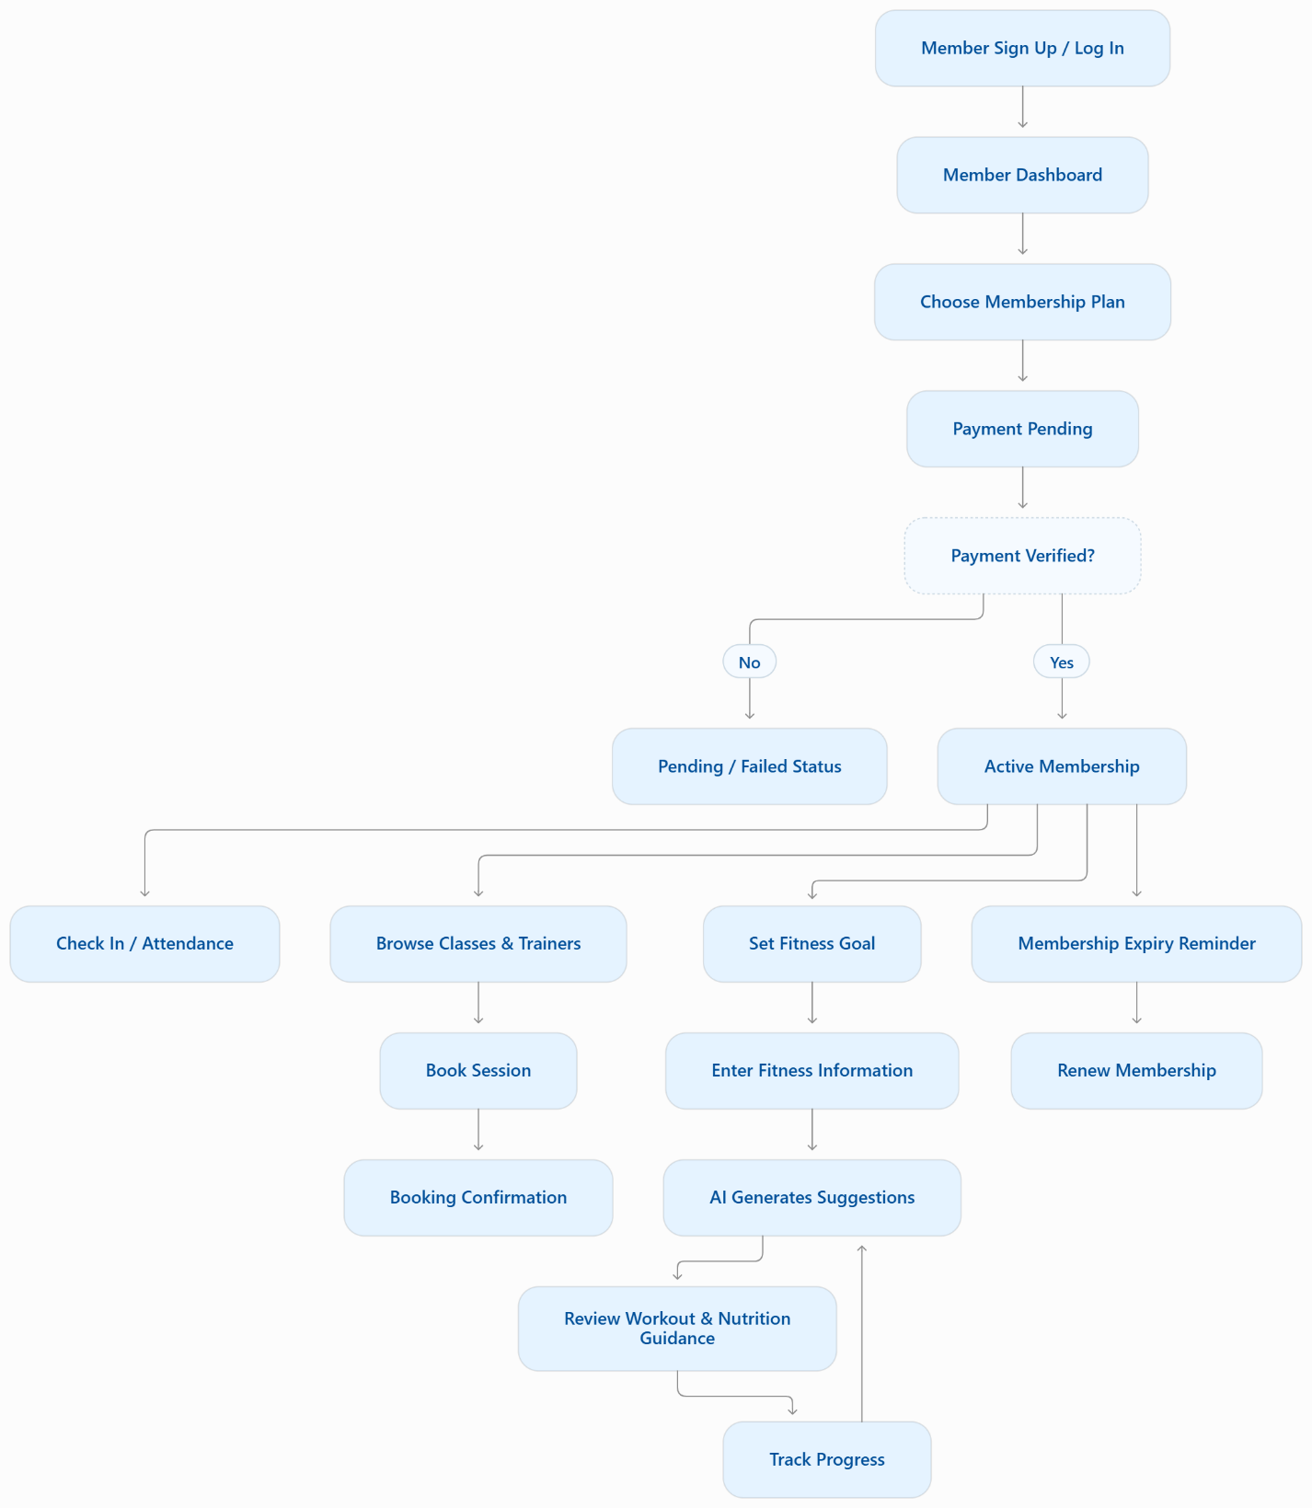

Member features and requirements
Feature | Expected Behaviour
Registration and profile | Create an account and manage basic profile information.
Membership | View available plans, current membership status, start date and expiry date.
Payments | View payment records, payment status and receipts where available.
Classes and trainers | Browse schedules, trainer profiles and available sessions.
Booking | Book and cancel sessions subject to the gym's rules and availability.
Attendance | View personal check-in history.
Fitness goals | Select weight loss, weight gain, muscle gain, general fitness or maintenance.
AI suggestions | Receive goal-oriented workout and nutrition suggestions based on provided information.
Progress tracking | Record measurements and review progress over time.
Notifications | Receive booking updates, payment updates and membership expiry reminders.
Feature | Expected Behaviour
Registration and profile | Create an account and manage basic profile information.
Membership | View available plans, current membership status, start date and expiry date.
Payments | View payment records, payment status and receipts where available.
Classes and trainers | Browse schedules, trainer profiles and available sessions.
Booking | Book and cancel sessions subject to the gym's rules and availability.
Attendance | View personal check-in history.
Fitness goals | Select weight loss, weight gain, muscle gain, general fitness or maintenance.
AI suggestions | Receive goal-oriented workout and nutrition suggestions based on provided information.
Progress tracking | Record measurements and review progress over time.
Notifications | Receive booking updates, payment updates and membership expiry reminders.

How the AI fitness assistant should work
The AI feature should be a guided workflow, not simply a text box where a member asks anything. The information collected could include:
- Fitness goal and target timeframe.
- Age range, height, current weight and target weight, when relevant.
- Training experience and available workout days.
- Equipment available and exercise preferences.
- Dietary preferences, allergies and food budget, if the member wants nutrition suggestions.
The AI can suggest beginner-friendly workouts, general nutrition habits, and realistic ways to monitor progress. It should not diagnose medical conditions or prescribe extreme diets. Recommendations should be conservative, flag relevant health concerns, and direct members to qualified healthcare or nutrition professionals when appropriate.
important product decision: AI recommendations are suggestions, not verified medical or professional training plans. Members should be able to review, edit, or decline them.
For the first version, implement the goal-selection form, a structured recommendation response, and progress tracking. Add an external AI model integration after the core membership and authorization workflows are stable.
4. Admin-side workflow
Yes — your understanding is correct. The Admin should be able to create, update, and deactivate trainer accounts, as well as create and manage membership plans.
I would make the Admin the central operator of the gym's business.
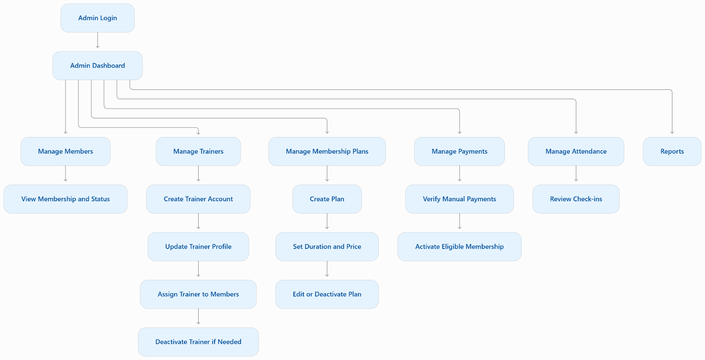

A. Trainer management
- Create a trainer account and profile.
- Update name, contact information, specialties, and availability.
- Assign or reassign members.
- View the trainer's schedule and assigned members.
- Deactivate a trainer when they leave the gym.
- Review session completion and workload.

B. Membership plan management
- Create plans such as 1, 3, 6, and 12 months.
- Set price, duration, benefits, and any applicable restrictions.
- Publish, edit, or deactivate plans.
- View the number of members enrolled in each plan.
- Review renewals and upcoming expirations.

C. Member management
- View, search, filter, and paginate members.
- View membership and payment history.
- Register members manually when needed.
- Handle membership status changes according to gym policy.
- Suspend or deactivate accounts when appropriate without erasing historical transactions.

D. Payments and reports
- Record and verify cash or other manually collected payments.
- Track pending, successful, and failed payments.
- Review daily and monthly attendance.
- Calculate revenue from recorded successful payments, accounting for refunds.
- Review active memberships and upcoming renewals.

Membership plan example
The Admin creates these plans in the application. They are examples, not proposed market prices.
Plan | Duration | Example price
Monthly | 1 month | PKR 3,000
Quarterly | 3 months | PKR 8,000
Half-yearly | 6 months | PKR 15,000
Annual | 12 months | PKR 27,000
Each plan should have fields such as name, duration Months, price, benefits, is Active, and timestamps.
A crucial rule: if a plan's price changes, members who already purchased it should retain their original purchase terms. Store the relevant price and plan details on the membership or purchase record rather than relying only on the current plan document.
Likewise, deactivating a plan must not delete existing memberships. It should prevent new purchases while preserving historical records.
5. Trainer-side workflow
The Trainer area is for delivering the gym's training services, not managing the entire business.

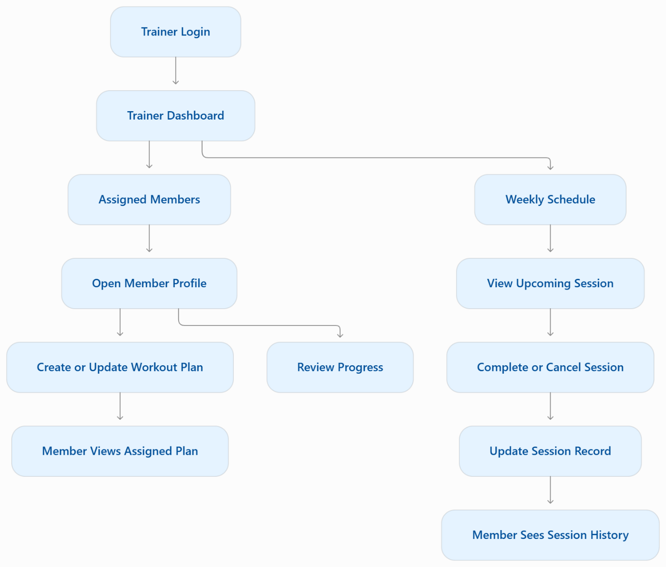
Trainer permissions should be limited to their assigned members and relevant training records. A trainer should not be able to change membership prices, verify payments, create admin accounts, or view unrelated members' private records.
If a trainer leaves, the Admin should be able to deactivate their account and reassign their members without losing historical session records.

6. Business rules we need to agree on
These rules are more important than the design of individual screens.
Area | Proposed rule
Authentication | One account per email, with server-side role checks.
Membership | A member cannot use membership-restricted services if their membership is expired or suspended.
Payments | Membership activation requires verified payment, unless an explicitly authorized alternative applies.
Plan changes | Existing purchases preserve their agreed terms.
Trainer removal | Deactivate the trainer and reassign members; preserve historical records.
Booking | Reject unavailable time slots and conflicting reservations.
Attendance | Record check-in time and member; prevent accidental duplicate check-ins.
AI | Recommendations are personalized guidance, with safety limits and user control.
Privacy | Members access their own records; trainers access only authorized assigned-member data.
Reporting | Dashboard figures must be calculated from actual records and use clearly defined metrics.
For payment and membership activation, the backend should update related records consistently. For example, if a payment verification fails, the system must not activate the membership just because the frontend displays a success message.

7. Proposed database structure
For React + Node.js + Express + MongoDB/Mongoose, I would start with these collections.
Collection | Main responsibility
Users | Login, profile, role, account status
trainers | Trainer-specific details, specialties and availability
Membership Plans | Duration, price, benefits and active status
memberships | Member's purchased plan, dates, status and agreed price
payments | Amount, method, status, verification and transaction reference
Trainer Assignments | Member-to-trainer relationships
classes | Class details, capacity and schedules
bookings | Class or personal training reservations
Workout Plans | Assigned workouts and exercises
attendance | Check-in records
Progress Records | Fitness measurements and progress over time
Ai Recommendations | Saved fitness goals and generated suggestions
notifications | Expiry reminders, booking updates and payment notifications
You don't necessarily need a separate trainers collection. For the initial version, you could store trainer-specific information in a profile document linked to users, while keeping authentication and roles centralized.
Likewise, you can defer classes, notifications, and saved AI recommendations until their corresponding features are implemented.

8. Proposed API structure
These endpoints illustrate how the frontend and backend could communicate.
Module | Example endpoints
Auth | POST /api /auth/signup, POST /api/auth/login, GET /api/auth/me
Plans | GET /api /plans, POST /api/plans, PATCH /api/plans/:id
Members | GET /api/members, GET /api/members/:id
Trainers | POST /api/trainers, GET /api/trainers, PATCH /api /trainers/:id
Memberships | POST /api/memberships, GET /api/memberships/me
Payments | POST /api/payments, PATCH /api/payments/:id/verify
Assignments | POST /api/trainer-assignments, GET /api/trainer-assignments/me
Bookings | POST /api/bookings, GET /api/bookings/me
Attendance | POST /api/attendance/check-in, GET /api/attendance/me
Workouts | POST /api/workout-plans, GET /api/workout-plans/me
AI | POST /api/ai/recommendations, GET /api/ai/recommendations/me
Reports | GET /api/admin/dashboard

These are starting proposals. For sensitive endpoints such as payment verification, trainer management, and AI requests, enforce authorization and validate all inputs on the backend.

9. Recommended development roadmap
I would divide the work into three releases.

Release 1 — Core gym management
MVP
Goal: a working gym application with real database-backed workflows.
- Authentication and role authorization.
- Admin creates and manages membership plans.
- Admin creates and manages trainer accounts.
- Members register and select a plan.
- Payment verification and membership activation.
- Basic member and Admin dashboards.
- Attendance check-in and history.

Release 2 — Training and scheduling
Goal: connect members and trainers through actual gym services.
- Trainer assignments and availability.
- Class schedules and personal training bookings.
- Workout plans and progress records.
- Membership expiry reminders.
- Search, filtering, pagination and reporting.

Release 3 — AI and advanced features
Goal: add differentiation after the core system is reliable.
- AI-assisted weight-loss and weight-gain guidance.
- Goal-based workout suggestions.
- Progress visualizations and recommendation updates.
- Optional payment gateway integration.
- Notifications and further operational automation.

